Document Authorization:

 | Name | Date | Signature
Owner |  | 04May2021 | See Signature on File
Operation Management |  | 04May2021 | See Signature on File
Operation Management |  | 04May2021 | See Signature on File
Quality Assurance |  | 04May2021 | See Signature on File

Changes from previous version:

Section | Summary of Changes | Change Control Number
ALL | - New document

- PURPOSE
This SOP outlines the procedure as to how chromatographic peaks should be integrated during oligonucleotide analysis. This includes a description as to when it is acceptable to use manual integration functions for integrating unresolved peaks. Further, this SOP is intended to provide instruction on integration and chromatographic data processing procedures across multiple software.
- SCOPE
This SOP applies to all lab employee who perform integration and data processing during the QC release process.
- INTERNAL REFERENCES
Document ID | Title
QUA001 | Quality Policy
- EXTERNAL REFERENCES
Document ID | Title
ISO9001 | Quality management
- RESPONSIBILITIES
Job Function and/or Department | Responsibility
All Personnel | It is the responsibility of all employees, including temporary employees and consultants, involved in recording, or reviewing information on documents to provide clear and consistent details on record keeping and follow good documentation practices to support the quality of work.
- DEFINITION
Term | Definition
(R)RT | (Relative) Retention Time
Rs | Resolution
LOD | Limit of Detection
LOQ | Limit of Quantitation
Blank | An injection where no sample is present. Typical blanks are sample diluent or mobile phases.
Peak | The peak is the portion of the chromatographic recording of the detector response when a single component is eluted from the column. If the separation is incomplete, two or more components may be eluted as one unresolved peak.
Integration | The process of calculating an area that is bounded in part or in whole by a curved line. The goal of chromatographic peak integration is to obtain retention times, heights, and areas of these peaks. Integration is performed using a chromatographic software either automatically or manually for quantitative purposes.
Automatic Integration | Automatic integration is performed using a chromatographic software with a processing method designed specifically with regard to the compound being analyzed. Processing methods can be designed manually or using a processing method wizard depending on the chromatographic software in use by the operator.
Manual Integration | Manual integration is performed using a chromatographic software when the processing method generated for the compound under analysis is not robust and generates an unacceptably integrated chromatogram. Examples of manual integration include repositioning the baseline, adding drop lines between unresolved peaks and removing integrations of baseline noise.
- PROCEDURE
  - Starting integration and LC processing
    - Visual review of blank chromatograms
      - When the U(H)PLC run is completed, visually review the blank chromatogram(s) to ensure there is no sample carryover from a previous analysis. Observe the solvent front and baseline that are characteristically specific to the method/gradient used for the LC analysis.
    - Visual review of sample chromatograms
      - When U(H)PLC run is completed, visually review the chromatograms to ensure peak heights are sufficient for proper analysis, typically between 0.1 – 1.2 AU. If peak heights are too low, improper integration can arise from elevated baselines. Conversely, if peak heights are too high, the instrument detector and/or column may be overloaded causing unwanted chromatographic effects (i.e. peak splitting/broadening) which can also lead to improper integration.
  - Choosing an appropriate processing method
    - Automatic integrations
      - Many chromatographic software offers automated processing methods that allow the user to integrate a chromatogram with the click of a button. This processing technique is mainly used for highly characterized compounds in a high throughput environment. Though beneficial for time management, these automated processing methods can produce improper integrations from sample to sample leading to inaccurate peak results. Therefore whenever automatic integration is used, all users must verify the integration was performed appropriately before submitting for review. This may require additional manual integration by the user.
    - Manual integrations
      - Manual integrations can be performed when the sample is not fully characterized, and careful consideration is necessary with respect to integration parameters. This type of processing method involves the user manually drawing the baseline (based on blank injection) and adding forced drop lines at the valleys between two fully resolved peaks or at peak inflections for two unresolved peaks. Peak areas in analytical chromatograms should be accurately and consistently integrated in a scientifically sound manner. The same integration parameters should be applied to all peaks in a sample set or sample sequence unless otherwise scientifically justifiable. This type of integration requires careful review by both user and reviewer to ensure integration is scientifically sound and the integrity of the generated result is not jeopardized.
  - Integration procedure and calculation
    - Overlay the test sample chromatogram with the blank chromatogram and integrate all peaks beyond the solvent front Manual integrations.
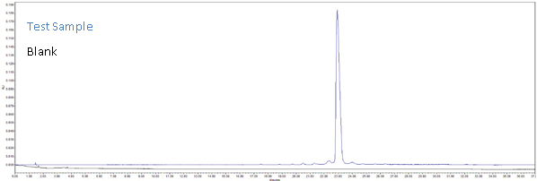
    - Integrate all peaks beyond the solvent front using the chromatography software with the guidelines given below
      - Using the chromatography software, draw a baseline for the peak cluster around the main peak
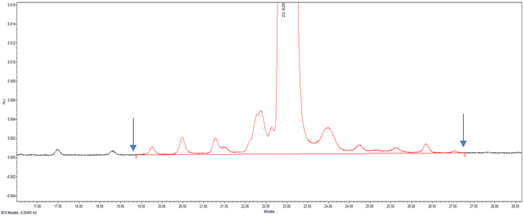
      - Draw vertical peak splits at valleys and shoulders to separately integrate peaks of interest.
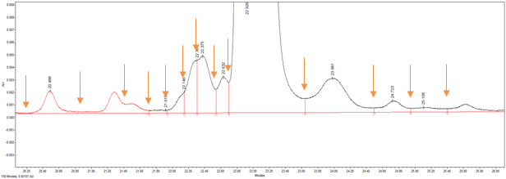
      - Integrate the early-eluting or late-eluting minor peaks individually while maintaining the baseline originally drawn around main peak cluster.
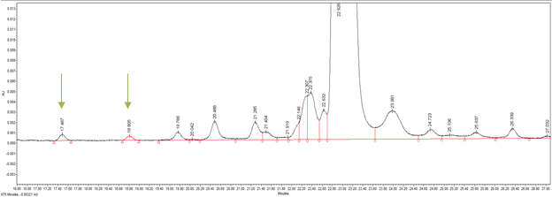
      - Once integration is complete, inhibit all peaks under reporting threshold (e.g. < 0.10% peak area normalized) unless otherwise specified in analytical method
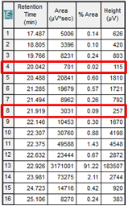
      - Save integrated test sample chromatogram and report/publish with the chromatography software as appropriate for reporting results. Best practice of reporting integrated LC results is to include sample/instrument method information, full-scaled integrated chromatogram, auto-scaled integrated chromatogram (around main peak cluster) and peak table of results detailing area, height and % AN by peak retention time. Other peak results such as Rs (USP) and RRT may be included.
    - Calculations
      - Typical calculations used in data analysis are outlined in this section. Additional calculations can be used where applicable.
      - Area percent of each peak is calculated by the software according to the formula.
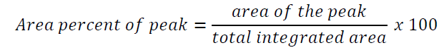
      - RRT is calculated using the following formula.
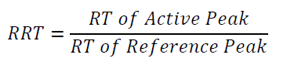
      - Rs is calculated by software according to the following formula.
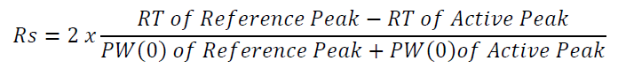
With RT of Reference Peak representing the retention time of the FLP, RT of Active Peak representing the retention time of the impurity marker, PW(0) of Reference Peak representing the peak with of the FLP measured at the baseline level and PW(0) of Active Peak representing the peak width of the impurity marker measured at the baseline level. See below diagram of USP Rs components.
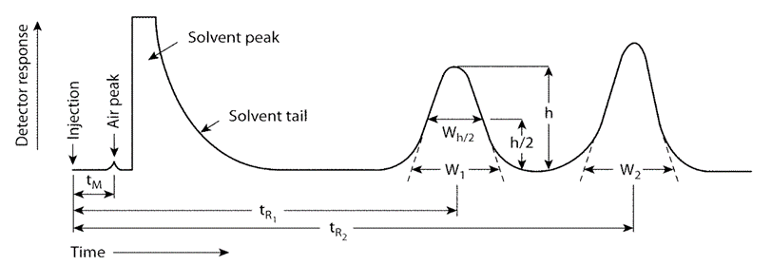
      - LOD and LOQ are ratios of peak signal-to-noise (S/N) determined from solutions that give ratios of approximately 3:1 and 10:1, respectively. S/N is calculated according to the following formula:
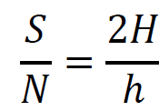
Where H is the height of the peak measured from the peak apex to a baseline extrapolated over a distance ≥5 times the peak width at its half- height; and h is the difference between the largest and smallest noise values observed over a distance ≥5 times the width at the half-height of the peak and, if possible, situated equally around the peak of interest. See below for S/N diagram
